**Practical Robotics Projects with Arduino**

**(CSE 4571)**

**Lab Assignment No – 04**

**ULTRASONIC & IR SENSING**

**Submission Date: _______________**

|  |  |  |
| --- | --- | --- |
| **Branch: CSE Section:** | | |
| **Name** | **Registration No.** | **Signature** |
|  |  |  |

Department of Computer Science and Engineering

Institute of Technical Education and Research (Faculty of Engineering)

**Siksha 'O' Anusandhan (Deemed to be University)**

**Bhubaneswar, Odisha-751030.**

# Aim:

# Ultrasonic & IR Sensing – To Interface HC-SR04 and IR sensors with Arduino UNO for distance measurement and obstacle detection.

# Objectives:

1. **To study the working principle of Ultrasonic (HC-SR04) and Infrared (IR) sensors.**
2. **To interface HC-SR04 ultrasonic sensor with Arduino UNO for distance measurement and display the output values on I2C LCD.**
3. **To interface IR sensor with Arduino Uno for obstacle detection using buzzer and LED.**
4. **To validate distance measurement of HC-SR04 ultrasonic sensor using LEDs as indicators.**

# Pre-Lab Questionnaire:

**A. Experiment-Specific**

1. What is the working principle of the HC-SR04 ultrasonic sensor for distance measurement?
2. Mention the function of Trigger pin and Echo pin in the HC-SR04 sensor.
3. Write the formula to calculate distance from the ultrasonic sensor using the speed of sound.
4. What is the typical range of distance measured by an HC-SR04 ultrasonic sensor?
5. What is the working principle of an Infrared (IR) sensor used for obstacle detection?
6. Differentiate between active IR sensor and passive IR sensor with examples.
7. State any two applications of ultrasonic sensors in real life.
8. Why is it necessary to use pinMode() and digitalWrite() functions in Arduino while interfacing sensors?
9. How does an IR sensor distinguish between the presence and absence of an obstacle?
10. Mention one key advantage and one limitation of ultrasonic sensors compared to IR sensors?

**Answers to Pre-Lab Questions**

Components/Equipment Required:

|  |  |  |  |
| --- | --- | --- | --- |
| **Sl.**  **No.** | **Name of the**  **Component / Equipment** | **Specification** | **Quantity** |
| **1)** | Arduino UNO R3 | 16MHz | 1 |
| **2)** | Arduino UNO cable | USB Type A to Micro-B | 1 |
| **3)** | Ultrasonic sensor HC-SR04 |  | 1 |
| **4)** | IR sensor module | Obstacle detection | 1 |
| **5)** | I2C LCD |  | 1 |
| **6)** | Buzzer |  | 1 |
| **7)** | Resistors (carbon type) | 220Ω / 330Ω | 2 |
| **8)** | LED | Any colour of your choice | 8 |
| **9)** | Breadboard | 840 Tie points | 1 |
| **10)** | Jumper Wire | --------------------------- | As per requirement |

**Objective 2**

**To interface HC-SR04 ultrasonic sensor with Arduino UNO for distance measurement and display the output values on I2C LCD.**

## Circuit / Schematic Diagram

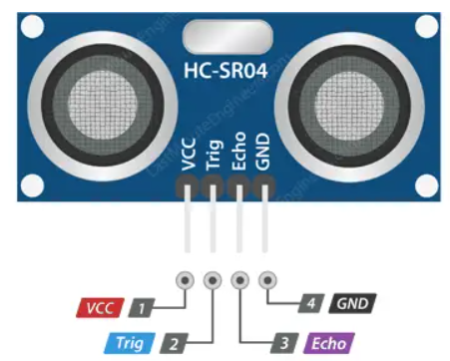

**Figure 1: *HC-SR04 Ultrasonic Sensor Pinout***

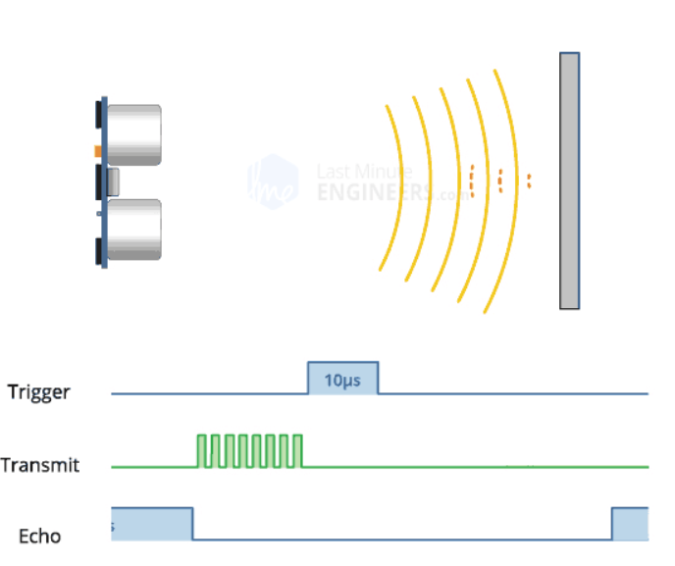

**Figure 2: *Work of HC-SR04***

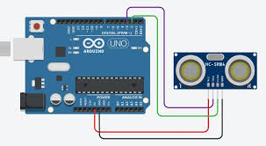

**Figure 3: *Ultrasonic Distance measurement circuit using HC-SR04 & Arduino Uno***

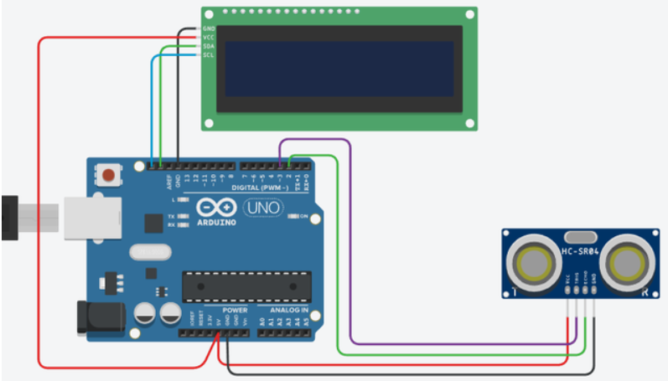

**Figure 4: *Ultrasonic Distance Measurement Output in LCD Display***

## Code

**Write an Arduino program to interface HC-SR04 ultrasonic sensor with Arduino Uno for distance measurement and display the output value in I2C LCD.**

**Figure 5: (Simuation based distance measurement using HC-SR04 ultrasonic sensor and output display in I2C LCD)**

**Figure 6: (Hardware Implementation based distance measurement using HC-SR04 ultrasonic sensor and output display in I2C LCD)**

## Observation

# Objective 3

**To interface IR sensor with Arduino Uno for obstacle detection using buzzer and LED.**

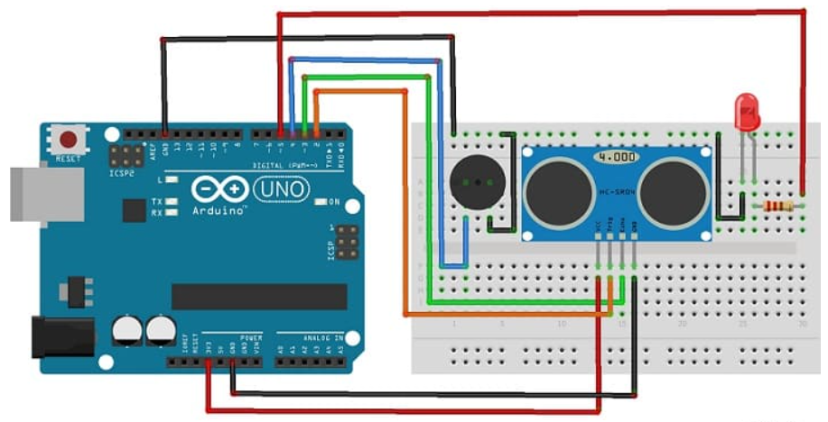

**Figure 7: *Interface IR sensor with Arduino UNO for obstacle detection***

## Code

**Write an Arduino program to detect an obstacle in front, and turn ON the LED and buzzer.**

**Observation**

**Figure 8: (*Simulation based* i*nterfacing IR sensor and buzzer with Arduino UNO for obstacle detection*)**

**Figure 9: (*Hardware Implementation of* i*nterfacing IR sensor and buzzer with Arduino UNO for obstacle detection*)**

Objective 4

**To validate distance measurement of HC-SR04 ultrasonic sensor using LEDs as indicators.**

## Circuit / Schematic Diagram

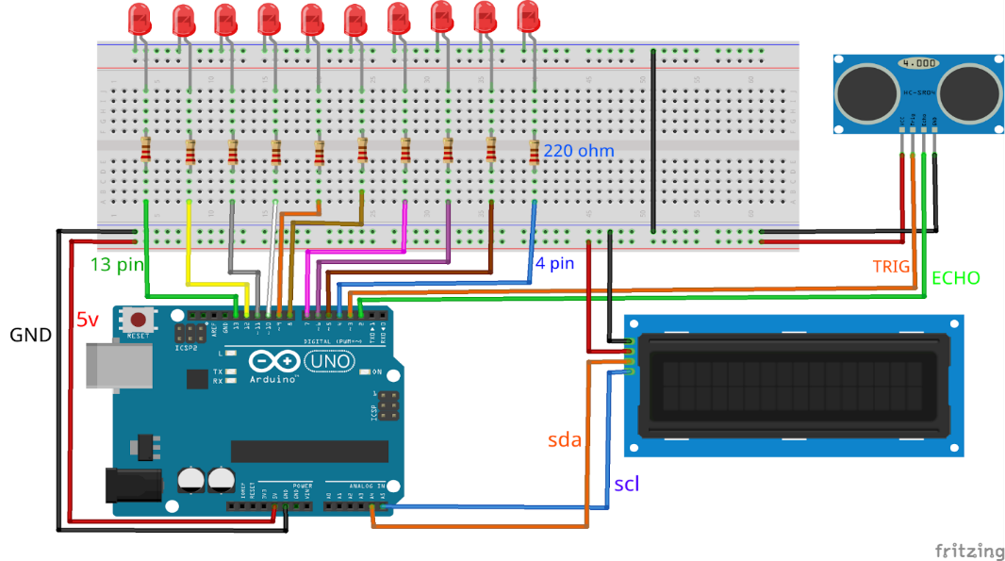

**Figure 10: *HC-SR04 + Arduino Uno +LCD+LED***

**Code**

**Write an Arduino program to integrate an ultrasonic sensor, an I2C LCD display, and LED indicators for real-time distance measurement and visualization.**

## Observation

**Figure 11: (*Software Implementation of* i*nterfacing ultrasonic sensor, an I2C LCD display, and LED indicators*)**

**Figure 12: (*Hardware Implementation of* i*nterfacing ultrasonic sensor, an I2C LCD display, and LED indicators*)**

**Conclusion:**

**Precautions:**

**Post Experiment Questionnaire:**

1. **Experiment-Specific (LED Blinking & LED Patterns)**
2. What happens if the Trigger pin of the HC-SR04 ultrasonic sensor is not given a proper 10 µs pulse?
3. If the Echo pulse duration is measured as 2 ms, calculate the distance of the obstacle. (Speed of sound = 343 m/s)
4. Why do ultrasonic sensors measure distance more accurately than IR sensors in outdoor conditions?
5. What would be the effect of bright sunlight on the IR sensor’s performance?
6. How can you modify the Arduino code to turn ON an LED when an obstacle is detected within 15 cm using the HC-SR04 sensor?
7. If the ultrasonic sensor reads 200 cm, what should be the approximate Echo pulse duration?
8. Why is it necessary to divide the total sound travel time by 2 in ultrasonic distance measurement?
9. What logic output does the IR obstacle sensor provide when an object is detected?
10. Mention one limitation of using only IR sensors for obstacle detection in mobile robots.
11. Suggest a practical application where both ultrasonic and IR sensors are used together for better performance.?

___________________________________________

|  |  |
| --- | --- |
| **(Signature of the Faculty)** | **(Signature of the Student)** |
|  | **Name:** |
| **Date:** | **Registration No.:** |
|  | **Branch:** |
|  | **Section** |